TOPIC: Screen recreation using blender and 3d modelling

Introduction :

As the need for small scale graphical 3d videos are increasing we will try to implement a screen recreation 3d videos .

Examples:
screen recreation of a life cycle of a bird
Cutscenes of minor video games

considering a scenario or an small animation, we will try to recreate it using tools like blender and 3d-modelling

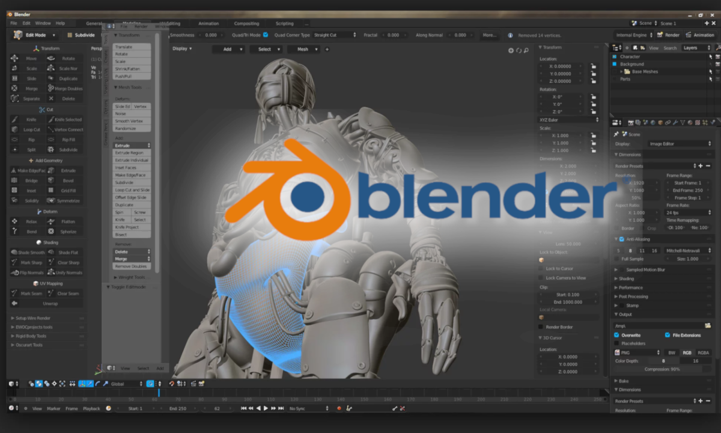

Dinesh Narayan - 19BCE1103
A Sadhun - 19BCE1505
Gopal
Sriman Tharun Kumar S - 19BCE1326

